**ST. THEREZA NAMILYANGO DIRLS’ BOARDING**

**END OF TERM I CONTINUOUS ASSESSMENT 2024**

**P.7 INTEGRATED SCIENCE**

***Time Allowed: 2 Hours 15 Minutes***

***Time Allowed: 2 Hours 15 Minutes***



**Candidate’s Name: __________________________________________________**

**Candidate’s Signature: ______________________________________________**

**District Name: _____________________________________________________**

**SECTION A (40 MARKS)**

1. Name one example of a pest that can be controlled by crop rotation.

______________________________________________________________________

2. Which state of matter has a definite volume and shape?

______________________________________________________________________

3. Mention any one non edible product from poultry.

______________________________________________________________________

4. Why do bees produce wax?

______________________________________________________________________

5. Why is a biogas digester not completely filled with plant and animal wastes?

______________________________________________________________________

6. Which advice can you give a person who is suffering from indigestion?

______________________________________________________________________

7. Name the component of blood that carries hormones in the body.

______________________________________________________________________

**The diagram below shows a compound leaf. Use it to answer questions 8 and 9.**

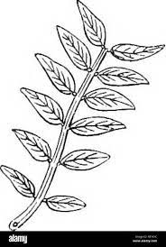

8. Name the compound leaf above.

______________________________________________________________________

9. Why is the leaf above grouped under compound leaves?

______________________________________________________________________

10. Why is it a bad habit to share clothes?

______________________________________________________________________

11. Give one role played by saliva during the process of digestion of food.

______________________________________________________________________

12. How does gonorrhoea lead to barrenness in women?

______________________________________________________________________

13. Mention the breeding place for the vector that spreads yellow fever.

______________________________________________________________________

14. What name is given to crops that take more than a year to mature?

______________________________________________________________________

15. State the energy change in a bulb before producing light.

______________________________________________________________________

16. Mention one condition under which a person can be immunized with tetanus toxoid vaccine.

______________________________________________________________________

**Use the diagram of an injury of the body below to answer questions 19 and 20.**

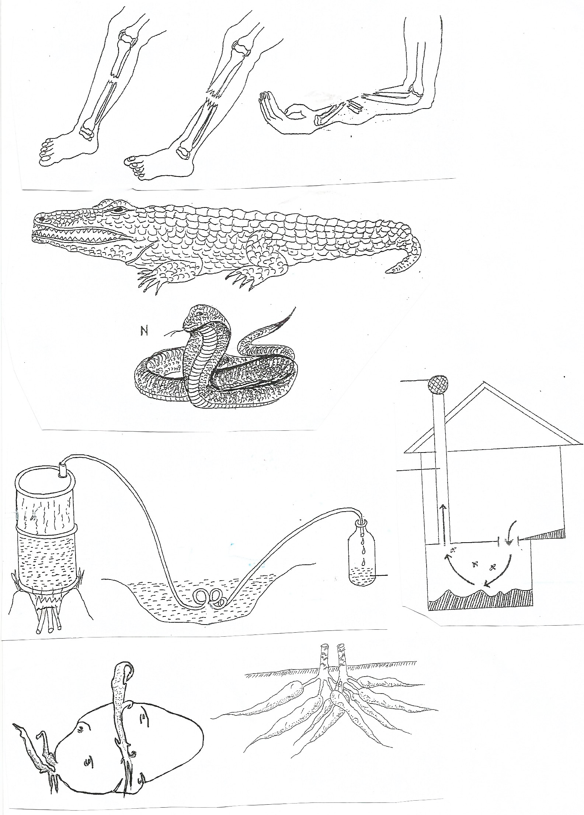

17. Name the body injury that requires the form of first aid above.

______________________________________________________________________

18. State the importance of the form of first aid shown in the diagram above.

______________________________________________________________________

19. Give one disadvantage of harvesting honey using fire.

______________________________________________________________________

20. Mention one method that can be used to separate solid mixtures.

______________________________________________________________________

21. Name one method of magnetisation which involves use of another magnet.

______________________________________________________________________

22. Give one advantage of regular weeding of crops.

______________________________________________________________________

23. Apart from having no back bone, give one other similarity between myriapods and arachnids.

______________________________________________________________________

24. How does the use of alternative sources of energy conserve non-renewable energy resources ?

______________________________________________________________________

25. Mention one part of the human ear that makes up the middle ear .

______________________________________________________________________

**The diagram below shows changes of state of matter. Use it to answer questions 26 and 27.**

Condensation Y

C

B

A

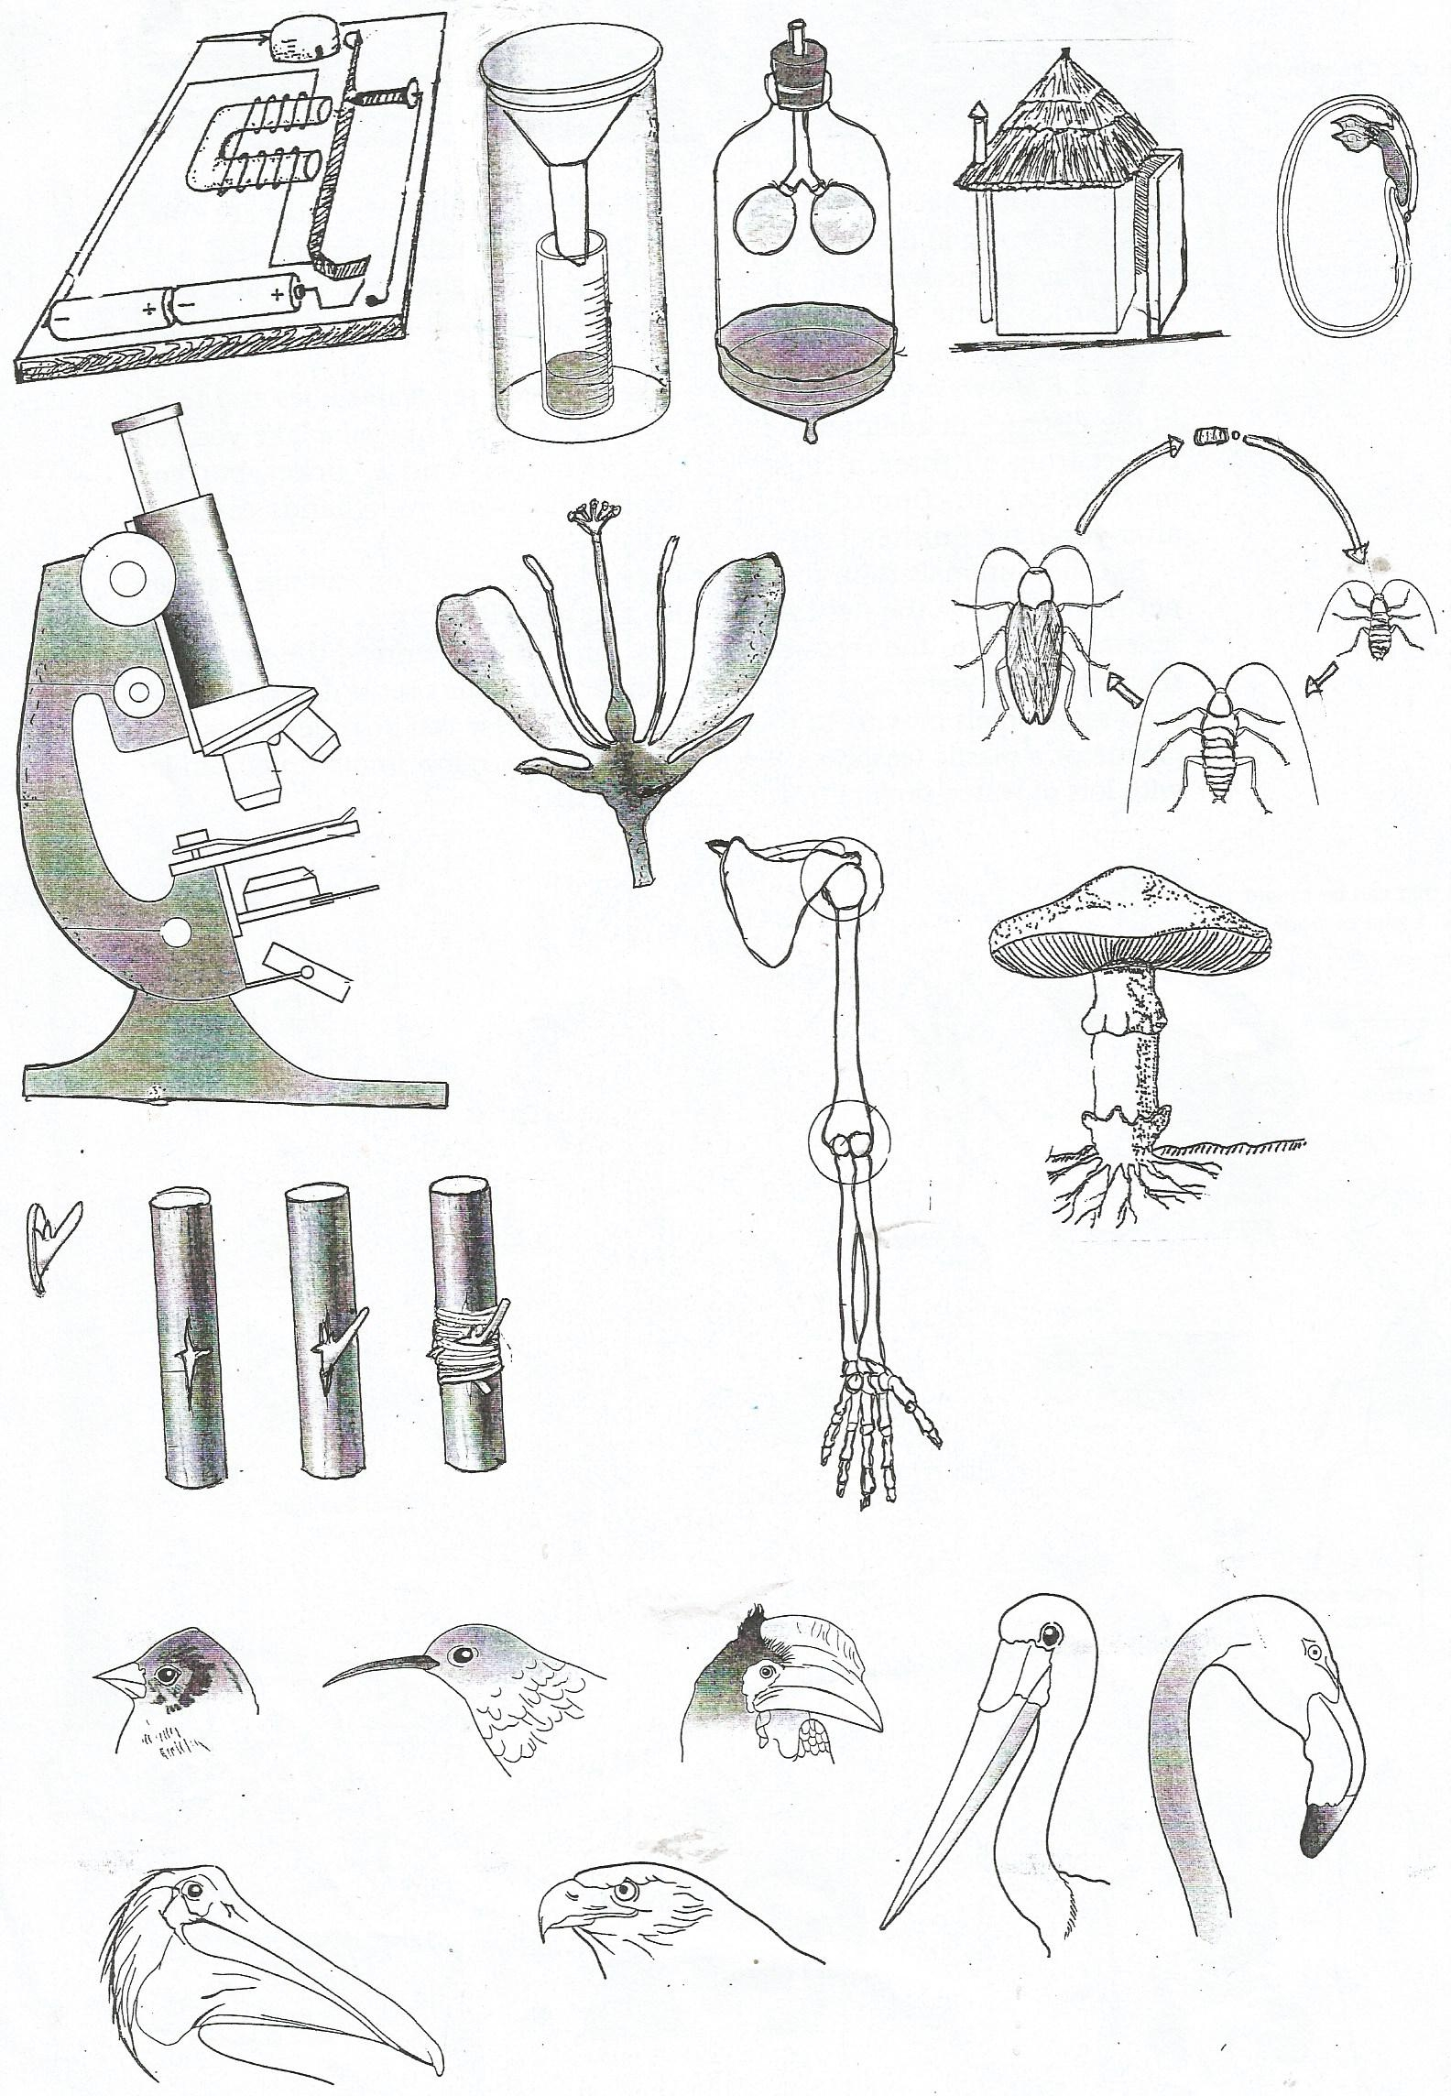

26. Which process of the changes in state of matter is represented by Y?

______________________________________________________________________

27. Give any one way in which condensation is important to people.

______________________________________________________________________

28. Mention one method of cooking that does not need water to be added when cooking.

______________________________________________________________________

29. Give the reason why yeast is added to dough when making bread.

______________________________________________________________________

30. State one problem a person may get due to poor personal hygiene.

______________________________________________________________________

31. Write one effect of soil erosion to soil.

______________________________________________________________________

32. Which weather instrument is used to measure the speed of wind?

______________________________________________________________________

33. Mention any one activity done by a family to promote P.H.

______________________________________________________________________

34. How is a tendon different from a ligament?

______________________________________________________________________

35. Why should the hole of an ordinary pit latrine be covered?

______________________________________________________________________

36. Give the importance of warmth during seed germination.

______________________________________________________________________

**The diagram below shows musical instruments. Use it to answer questions 37 and 38.**

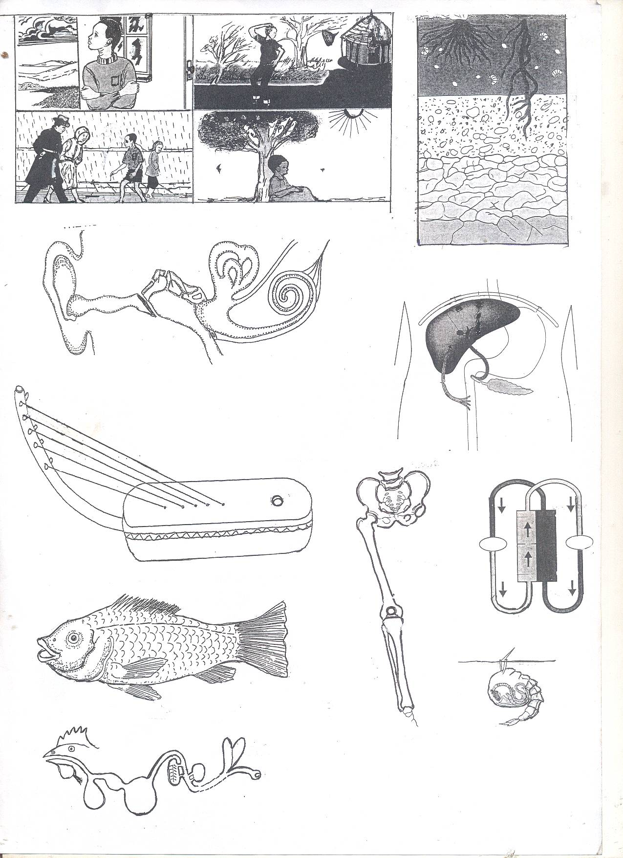

**B**

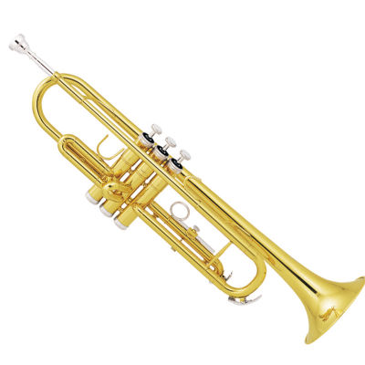

**A**

37. Name the musical instrument labelled B.

______________________________________________________________________

38. Why is musical instrument A grouped under stringed musical instruments?

______________________________________________________________________

39. How can the problem of drug dependence be solved in the community?

______________________________________________________________________

40. Mention any one type of chicken kept by people.

______________________________________________________________________

**SECTION B 60 MARKS**

41(a) Give the meaning of teenage pregnancy.

______________________________________________________________________

______________________________________________________________________

(b) State any two ways in which teenage pregnancy affects a P.7 girl.

(i)_____________________________________________________________________

(ii)____________________________________________________________________

(c) What advice can you give a P.7 girl to protect her from teenage pregnancy?

______________________________________________________________________

42(a) Mention any one component of a home where germs can multiply easily if poorly maintained.

______________________________________________________________________

(b) State one condition which helps germs to breed.

______________________________________________________________________

(c) Give any two activities people carry out to control the multiplication of germs in their homes.

(i)_____________________________________________________________________

(ii)____________________________________________________________________

43. **The diagram below shows a method of grazing cattle. Use it to answer the questions that follow.**

(a) Name the above method of grazing in the diagram above.

______________________________________________________________________

(b) Mention one disease in cattle controlled by the method of grazing above.

______________________________________________________________________

(c) How does the method above control the disease mentioned in “**b**” above?

______________________________________________________________________

(d) Apart from disease and parasite control, state one other advantage of the above method of grazing.

______________________________________________________________________

44(a) State the cause of the following food deficiency diseases.

(i) marasmus________________________________________________________

(ii) kwashiorkor _______________________________________________________

(b) How can food deficiency diseases be prevented in a family?

______________________________________________________________________

(c) Give one way of protecting cooked food from contamination.

______________________________________________________________________

45(a) Name the device used at home to keep hot things hot and cold things cold.

______________________________________________________________________

(b) Mention the part of the device named above which prevents heat gain or loss by:

(i) radiation___________________________________________________________

(ii) conduction and convection________________________________________

(c) Why does the cork of the device above prevent heat gain or heat loss by conduction.

_____________________________________________________________________

46. **The diagrams below are of garden tools. Use them to answer the questions that follow.**

**A B C**

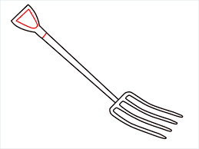 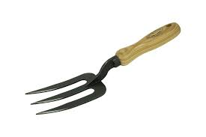 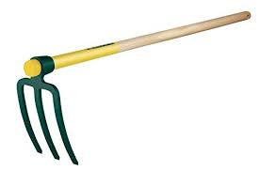

(a) Name the garden tools labelled **B** and **C**.

(i) **B** __________________________________________________________________

(ii) **C** _________________________________________________________________

(b) Which of the above garden tools is used for turning manure in a compost pit?

______________________________________________________________________

(c) State any one way of promoting the efficiency of the above garden tools.

______________________________________________________________________

47(a) Give two reasons why electric wires in a house should be covered with insulators.

(i)_____________________________________________________________________

(ii)____________________________________________________________________

(b) Apart from covering electric wires, state any one other use of insulators to people.

______________________________________________________________________

(c) Why is distilled water unable to conduct electricity?

______________________________________________________________________

48. **The table below shows parts of the respiratory system and their behaviour during inhalation and exhalation**. **Study and** **complete it.**

|  |  |  |
| --- | --- | --- |
| **Respiratory** | **Inhalation** | **Exhalation** |
| (i)__________________ | moves downwards and flattens  ………………………… | ____________________ |
| (ii)ribcage | ___________________ | moves downwards and inwards |
| (iii)intercostal muscles | They contract | ____________________ |

49(a) Give any two causes of swarming in bees.

(i)_____________________________________________________________________

(ii)____________________________________________________________________

(b) State any two ways in which bee farmers can prevent swarming in bees.

(i)_____________________________________________________________________

(ii)____________________________________________________________________

50(a) Name the vaccine administered to infants on the left upper arm.

______________________________________________________________________

(b) At what age is the vaccine named above administered to the infants?

_____________________________________________________________________

(c) Why is the vaccine administered to infants at the age stated in “**b**” above?

______________________________________________________________________

(d) Give any one role of a Primary Seven pupil in promoting immunization.

______________________________________________________________________

51. **Match the first aid items in** List A **to their functions in** List B **correctly.**

**A B**

- to disinfect wounds

- for tying a sprained joint

- for fastening bandage

- to cover wounds to keep away dirt

(i) plaster

(ii) safety pins

(iii) iodine solution

(iv) bandage

**Correct order**

(i) plaster _________________________________________

(ii) safety pins _________________________________________

(iii) iodine solution _________________________________________

(iv) bandage _________________________________________

52(a) Which method of obtaining clean water involves:

(i) gentle pouring of clean water on top into another container?

_____________________________________________________________________

(ii) heating water at boiling point and condense the vapour?

_____________________________________________________________________

(b) How can water obtained by filtration be made safe for drinking?

_____________________________________________________________________

(c) How can safe water for drinking be protected from contamination?

_____________________________________________________________________

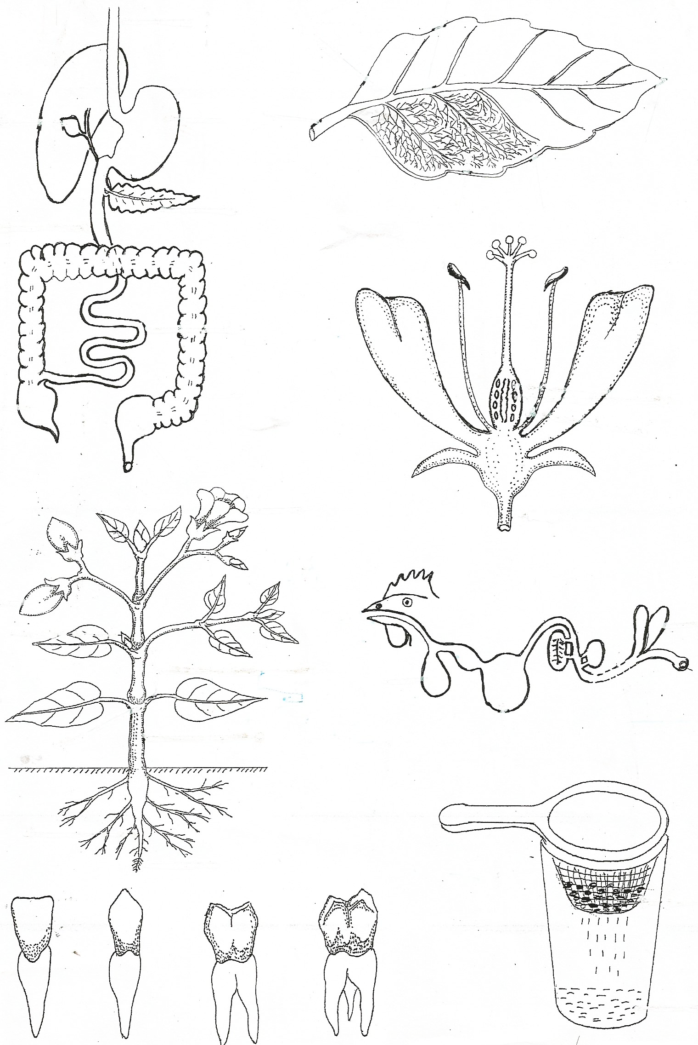53. **The diagram below shows a body system. Use it to answer the questions that follow.**

P

liver

(a) Name the body system above.

_____________________________________________________________________

(a) Give the importance of the system above to the body.

_____________________________________________________________________

(c) Mention one disease which affects organ labelled P.

_____________________________________________________________________

(d) How can the body system above be kept in good working condition?

_____________________________________________________________________

54(a) Which wood fuel is obtained by burning wood under limited supply of oxygen?

_____________________________________________________________________

(b) Give any two ways of conserving trees in our environment.

(i)_____________________________________________________________________

(ii)____________________________________________________________________

(c) State any one danger of uncontrolled cutting down of trees.

_____________________________________________________________________

55(a) Which disease of blood is described as blood cancer?

_____________________________________________________________________

(a) Mention one disease of blood that affects red blood cells.

_____________________________________________________________________

(c) How does lack of enough iron affect the body?

_____________________________________________________________________

(d) State one form of advice you can give someone in order to avoid high blood pressure.

_____________________________________________________________________

**~END~**